Welcome to Laguna Key

- The beach entrance is in the center of Laguna Key, across from the community pool. This is the only entrance to the beach. Do not cross any other property to access the beach.

- The community pool is in the center of the complex, across from the beach access. Tennis courts / basketball goals are located next to the pool.

- There is a community pier shown on the attached map. All other docks are private property.

- Trash pickup is Monday, Thursday, and Saturday. Laguna Key moves your trashcans to and from the street.

- No vehicles may be parked on the street or grass -- they will be towed immediately and without warning. Park in the driveway or garage of your rental.

- No campers, RVs, motor homes, trailers, or boat trailers are permitted in Laguna Key.

- For everyone’s safety, Laguna Key has 24-hour video surveillance.

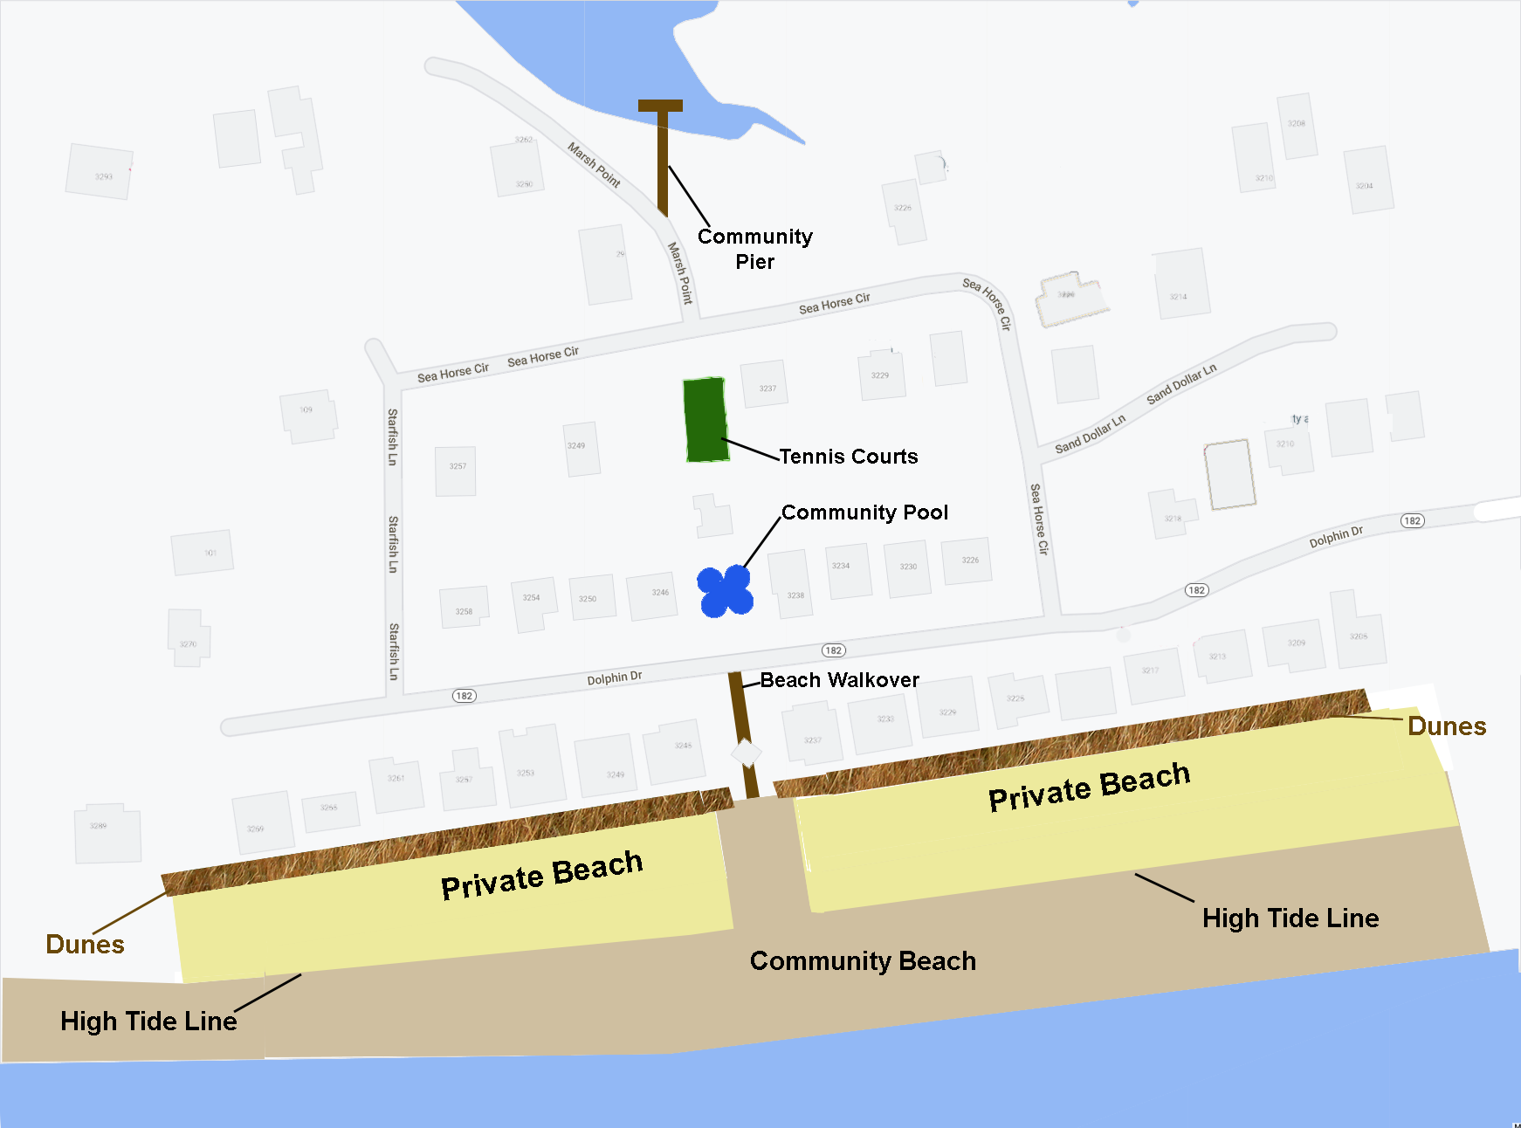

RULES OF LAGUNA KEY
GENERAL
- There must be a person 24 years of age or older staying with the rental group in each house.
- Outside music, noise, and partying must cease by 10 pm. Many families have small children.
- Houses are private property and entering the grounds of any house other than your rental is trespassing. Most houses are owner occupied and they take their security seriously.
BEACH
- Remove all beach equipment, chairs, etc. by dusk. No equipment may be stored on the beach or walkover.
- Dunes are fragile and no one may walk on them. It is illegal to step on sea oats (sea grass).
- Please do not leave any trash on the beach.
- No fires or glass containers are allowed on the beach.
- The public beach area is the area 75 feet wide between the houses on either side of the walkover, and below the highest tide line (see map, usually the highest seaweed marks the high tide line). The beach above the highest tide line is private property.
POOL
- The pool has no lifeguards, swim at your own risk. Laguna Key HOA is not responsible for any accident, injury, or loss of property in the pool area.
- Children must be accompanied by an adult.
- No glass containers are allowed in the pool area.
- The pool closes at 10 pm.
- No diving in the pool by anyone, ever.
TENNIS AND BASKETBALL COURTS
- If it has wheels or paws, it is not allowed on the courts.
- The courts close at 9 pm.
PETS
- Dogs must be leashed at all times.
- Pets are not allowed on the beaches (Gulf Shores Regulation, $500 fine).

GOLF CARTS AND 3 WHEELERS
- Electric Golf Carts may be driven on paved streets only.
- Gas Carts are not permitted.
- The speed limit within Laguna Key is 15 MPH.
- Golf carts my not be operated by anyone under 16 years of age
- 2 riders per bench seat maximum, no standing riders ever.
- Golf carts must have working headlights.
- No games may be played on golf carts.
- Pedestrians always have the right of way.
- Golf Carts, Bikes, Scooters, Skateboards, etc. must remain on the paved areas. No wheeled vehicle may be on sidewalks, boardwalks, around the pool or tennis courts, or on any grass surfaces.

Security: Inner Parish Security (251) 533-0600
Police: (251) 968-2431

If security is called for any violation the homeowner will be fined $200, which they may bill to the renter.

